**Project Design Phase-II**

**Technology Stack (Architecture & Stack)**

|  |  |
| --- | --- |
| Date | 19 September 2023 |
| Team ID | **593090** |
| Project Name | |  | | --- | | TrafficTelligence: Advanced Traffic  Volume Estimation with Machine Learning | |  | |
| Maximum Marks | 4 Marks |

**Technical Architecture:**

The Deliverable shall include the architectural diagram as below and the information as per the table1 & table 2 **Example: Order processing during pandemics for offline mode**

**Reference: https://developer.ibm.com/patterns/ai-powered-backend-system-for-order-processing-during-pandemics/**

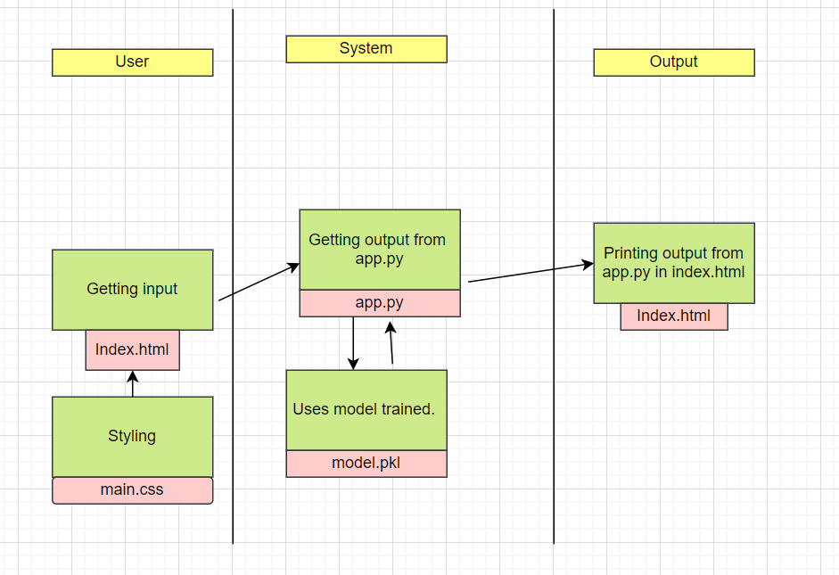**Guidelines:**

1. Include all the processes (As an application logic /Technology Block)

2. Provide infrastructural demarcation (Local / Cloud)

3. Indicate external interfaces (third party API’s etc.)

4. Indicate Data Storage components / services

5. Indicate interface to machine learning models (if applicable)

**Table-1: Components & Technologies:**

|  |  |  |  |
| --- | --- | --- | --- |
| **S.No** | **Component** | **Description** | **Technology** |
| 1. | User Interface | How user interacts with application e.g.  Web UI or how the user finds out the output from the model after giving the inputs etc. | HTML, CSS. |
| 2. | Application Logic-1 | Logic for a process in the application | Python |
| 3 | File Storage/Data | File storage requirements for storing the data | Local System. |
| 4 | Framework | Used to Create a web Application, Integrating Frontend and Back End | Python Flask |
| 5 | Machine Learning Model | The Purpose of Machine Learning Model is to predict the traffic volume on a particular day. | Traffic detection Model, etc. |
| 6 | Infrastructure (Server / Cloud) | Application Deployment on Local System / Cloud Local Server Configuration:  Cloud Server Configuration: | GitHub, Local, |

**Table-2: Application Characteristics:**

|  |  |  |  |
| --- | --- | --- | --- |
| **S.No** | **Characteristics** | **Description** | **Technology** |
| 1. | Open-Source Frameworks | List the open-source frameworks used | Python’s Flask |
| 2. | Security Implementations | List all the security / access controls implemented, use of firewalls etc. | e.g., SHA-256, Encryptions, IAM Controls, OWASP etc. |
| 3. | Scalable Architecture | Justify the scalability of architecture (3 – tier, Micro-services) | Technology used |

|  |  |  |  |
| --- | --- | --- | --- |
| **S.No** | **Characteristics** | **Description** | **Technology** |
| 4. | Availability | Justify the availability of application (e.g., use of load balancers, distributed servers etc.) | Technology used |
| 5. | Performance | Design consideration for the performance of the application (number of requests per sec, use of Cache, use of CDN’s) etc. | Technology used |

**References:**

**https://c4model.com/**

**https://developer.ibm.com/patterns/online-order-processing-system-during-pandemic/**

**https://www.ibm.com/cloud/architecture**

**https://aws.amazon.com/architecture**

**https://medium.com/the-internal-startup/how-to-draw-useful-technical-architecture-diagrams-2d20c9fda90d**